**Opioid Treatment Program (OTP)**

**1.0 Executive Summary**

According to Nazaroff (2020), Opioids nearly doubled in prevalence between 2006 and 2015, being the most often discovered drug class in fatal drug toxicity cases in Sydney. The majority of fatal drug toxicity cases in Sydney (71%) were caused by accidental overdoses, which commonly occurred in the deceased's home. Therefore, it is essential that the opioid dependent patients can find pharmacies to take OTP service regularly. Final goals of this project aim to provide opioid dependent patients more convenience for accessing pharmacies and services, help them to detoxify and improve the sustainability of pharmacy operations, especially under the pandemic circumstances.

**2.0 Final Project Scope**

The core service of the CCPC pharmacy is medicine dispensing. The new package adds the Opioid Treatment Program to the basic medicine dispensing service. The target customers of the new package are opioid dependent patients who need opioid treatment. To better serve the patients, the pharmacy will be open from Monday to Sunday in case that the patients need opioid treatment at any time.

The Opioid Treatment Program (OTP) provides opioid replacement therapy for people who are dependent on opioids such as heroin, morphine and oxycodone. It helps people stop their illicit or problematic use of opioids and reduce the harms that come about from such use. The patients can stay drug- free to live a healthy lifestyle（NSW health，N.A.). At the beginning of the treatment, patients will dose in the pharmacy under supervision. Later with permission from the doctor, patients can get takeaway doses.

Due to the pandemic, some opioid dependent patients cannot travel to the pharmacy, the pharmacy will also provide home delivery service for self-isolation patients after confirmation that self-isolation is clinically required for the patients. Then the service for any patient in self-isolation will need to be individually planned, the dose could be prepared every morning and sent out in the afternoon.

The final goals of CCPC Parramatta are mainly:

* Provide more service conveniency for more opioid dependent patients.
* Provide convenience for opioid dependent patients in self-isolation under Covid.
* Help more opioid dependent patients to get rid of opioids.
* Improve the sustainability and profitability of CCPC Parramatta.

**3.0 New Package Blueprint**

**3.1 Process description**

According to the Opioid Treatment Program Resource Manual of the NSW, when an opioid-dependent patient comes in, the pharmacist needs to first identify the patient by matching the ID with the prescription. Then the pharmacist must speak to the patient to conduct an intoxication assessment. If the patient is intoxicated, the patient is required to come back later to reassess. If the patient passes the assessment, the pharmacist prepares the dose according to the patient’s prescription. The dispensed dose has to be recorded in the drug register system. Then if the patient is allowed to take away the dose, the pharmacist can hand the takeaway dose to the patient and check out. If the patient is required to take a supervised dose, the pharmacist gives the one-time dose to the patient and observes and confirms the patient consumes the dose.

Responding to the Covid-19 outbreak, the delivery service for patients in self-isolation required clinically is allowed by the NSW government. Since this service for any patient in self-isolation will need to be individually planned, the dose could be prepared every morning by a locum pharmacist and sent out in the afternoon by a practice assistant. The service will be only for patients that are allowed takeaway dosing since any adult nominated by the pharmacist can deliver the opioids for such patients per the NSW government. The pharmacist needs to confirm that isolation is clinically required when receiving opioid dispensing for patients in self-isolation. Then an individual plan will be documented for the patient. The pharmacist then prepares the doses for any recorded patients that are in self-isolation every morning and hands them to the practice assistant for delivery. The practice assistant will deliver the doses in the afternoon. The practice assistant must identify the patients before handing the doses to them. The delivery will be finished after collecting the payment. Details could be reflected in Figure **1.**

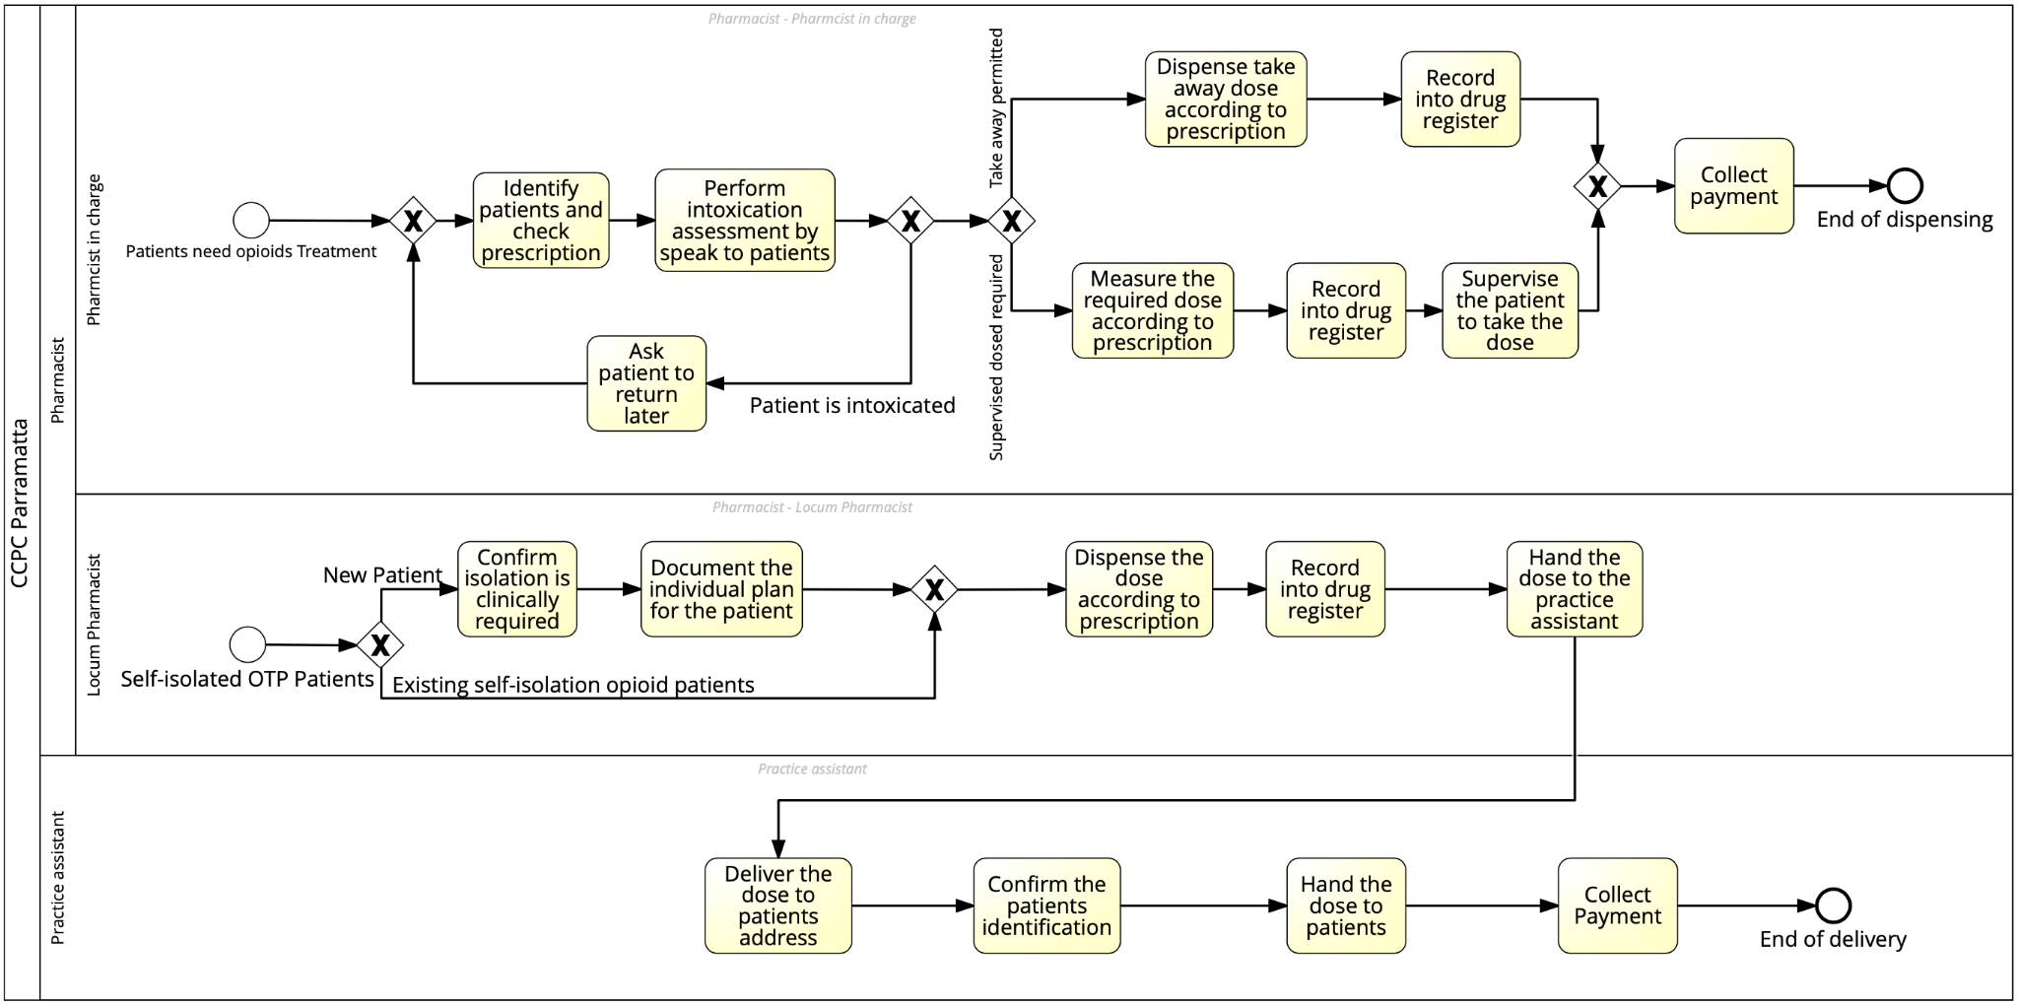

**Figure 1.** BPMN of CCPC Parramatta OTP dispensing process

**3.2 Technology involvement**

With a rapid development in medical and computing, the combination of technology and medical treatment has become a trend. Electronic prescription is an important policy to promote the development of the medical industry (Mehmood et al., 2019). It is controlled by the patient which pharmacy can access the e-prescription that has been transmitted to the prescription exchange (Fred, n.d.). The e-prescription brings lots of conveniences and benefits to pharmacies, doctors and patients. OTP patients who are inconvenient, and isolated can choose the delivery service of the pharmacy by showing their e-prescription. The medications will be delivered to nominated persons by at least two staff members (Lintzeris et al., 2020). And the patient's relevant certificates, such as e-prescription and ID, will be checked. Besides, compared with the paper prescription, the e-prescription saves patients the trouble of losing it. Because patients can retrieve their lost prescriptions through the media that received e-prescriptions before, such as SMS, email, etc. For doctors, they can get to know their patients more quickly through the past e-prescriptions, thus improving their work efficiency. Secondly, e-prescription ensures the safety of prescription, and patients, especially OTP patients, can't change the prescription content without permission, therefore avoiding many potential risks. Another aspect of benefit from the e-prescription is the pharmacy. This will allow the pharmacists to validate the prescriptions and pharmacies are also able to save their data in a computer-based system instead of a file-based system, which allows the system to be flexible. It makes the management process easier, reduces the cost of managing inventory data and ensures the integrity of user data. (Mehmood et al., 2019).

**3.3 Process simulation and results**

**Simulation set up**

Cost:

The only task that has overhead cost is delivery fee, which costs around 10 AUD per delivery.

Duration:

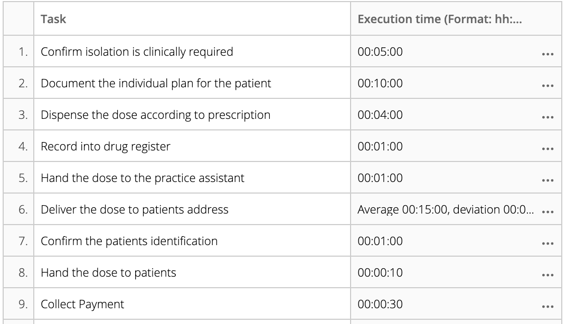

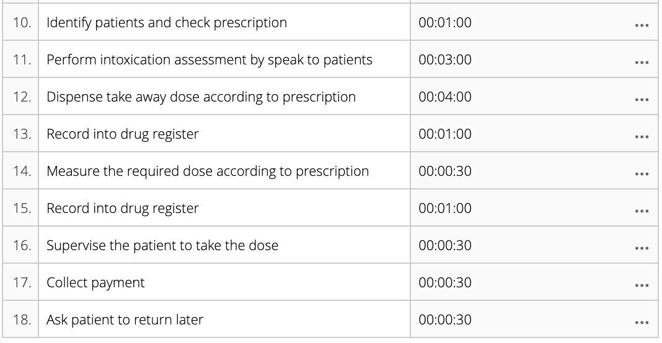

Frequency:

The pharmacy will change its operation day to 7 days a week.

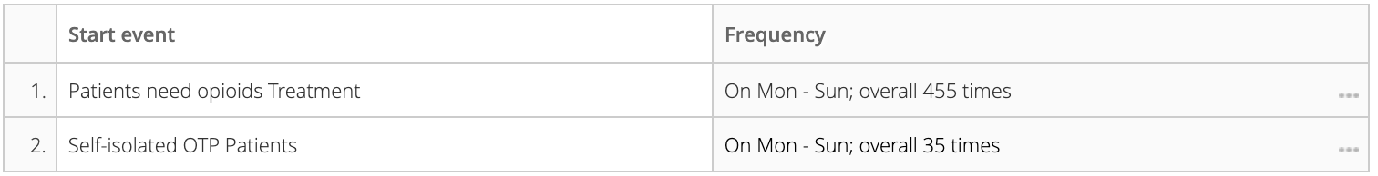

The pharmacy will only receive and make individual delivery plans for self-isolated patients in the morning. All doses for self-isolated patients will also be prepared in the morning only.

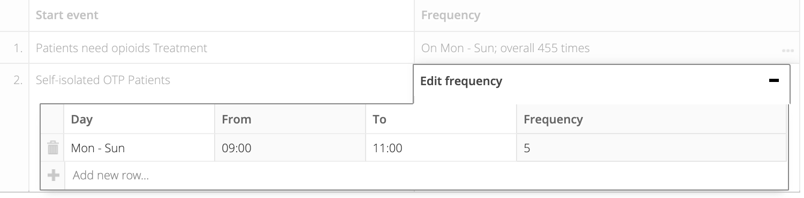

The simulation will run for only 1 day since all dispensing and delivery service will conduct and finish within the day. In the multiple day simulation, there will be some instances that arrives at the closing time and continues executing the next day since there’s no resource to process the instance at night time, which may affect the maximum cycle time.

**Worst scenario**

There's no additional resources after the implementation of the new OTP service. The pharmacy will still have 1 pharmacist in charge, 1 locum pharmacist and 1 practice assistant. The pharmacy will adopt 65 walkin patients and 5 self-isolated patients.

**The most likely scenario**

Adding 1 pharmacist in charge based on the worst scenario.

**Best scenario**

Adding 1 practice assistant based on the most likely scenario

**Result:**

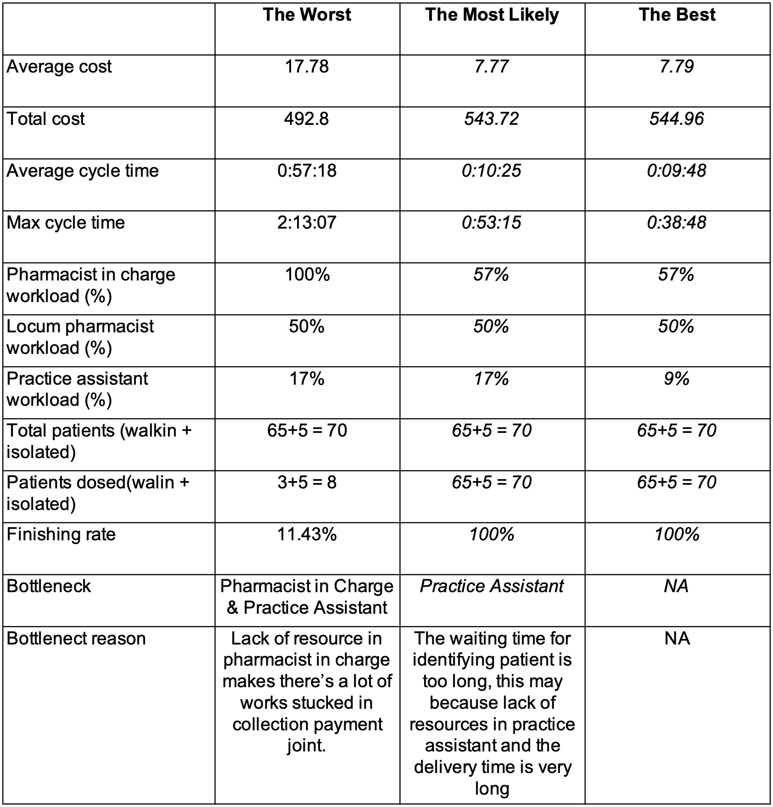

The majority difference between the worst and the most likely is the cycle time due to the work load for the pharmacist in charge to much. The difference between the best and the most likely is not significant, adding a practice assistant can remove the bottleneck, but there’s no significant improvement in terms of cost and cycle time.

**3.4 Benefits & Impact**

The relevant stakeholders can be analyzed from different levels, such as, the national, the community, the pharmacy, and patients. Analysis from national level, the expansion of OTP by the pharmacy has alleviated the public health problems for the government. Because those addicts will have one more place for detoxification, not just a drug rehabilitation center set up by the state, which will reduce the management pressure of the state. However, it has increased the pressure on the drug rehabilitation departments because this new package for pharmacies requires the regulatory authorities to introduce more targeted and stronger regulatory policies. For the community, it may attract more addicts to move in and bring many conveniences for opioid dependent residents. But at the same time, it will also bring security risks, which will cause the concern of local normal citizens and lead to their loss. The pharmacy used to provide basic services just like normal pharmacies. The change of the pharmacy brings a new revenue-generating project to the pharmacy. However, the pharmacy needs to train relevant pharmacists to meet the government's requirements for OTP policy. Finally, it is worth mentioning that the community pharmacy has added this service, which will bring great convenience to those addicts in detoxification. Because when addicts take opioids, the supervision of pharmacists ensures their safety, and the setting of pharmacy addresses brings convenience to the transportation of addicts.

**4.0 Implementation**

**4.1 Project plan**

Firstly, our group reports consultation results to CCPC management and gets confirmation in. the first week. Then obtaining approval to be a dosing point from the Pharmaceutical Regulatory Unit of NSW health in the 2nd week. Announcing changes to the pharmacy staff and should be done until the 4th week. Staff training happened in week 3 & 4. Meanwhile, in the 4th week, we announce a new OTP service to the community and start implementing the new process until the 5th week.

Also, in the 5th week, we start drawing up KPI and monitoring the process until the 7th week. From the 7th week to 8th week, we gather staff feedback for a 2 weeks run. From the 8th week to the 9th week, we claim improvement review by conducting change management analysis. Next, we formulate an impact mitigation plan in the 10th week. Lastly, we execute a mitigation plan in the 11th week.

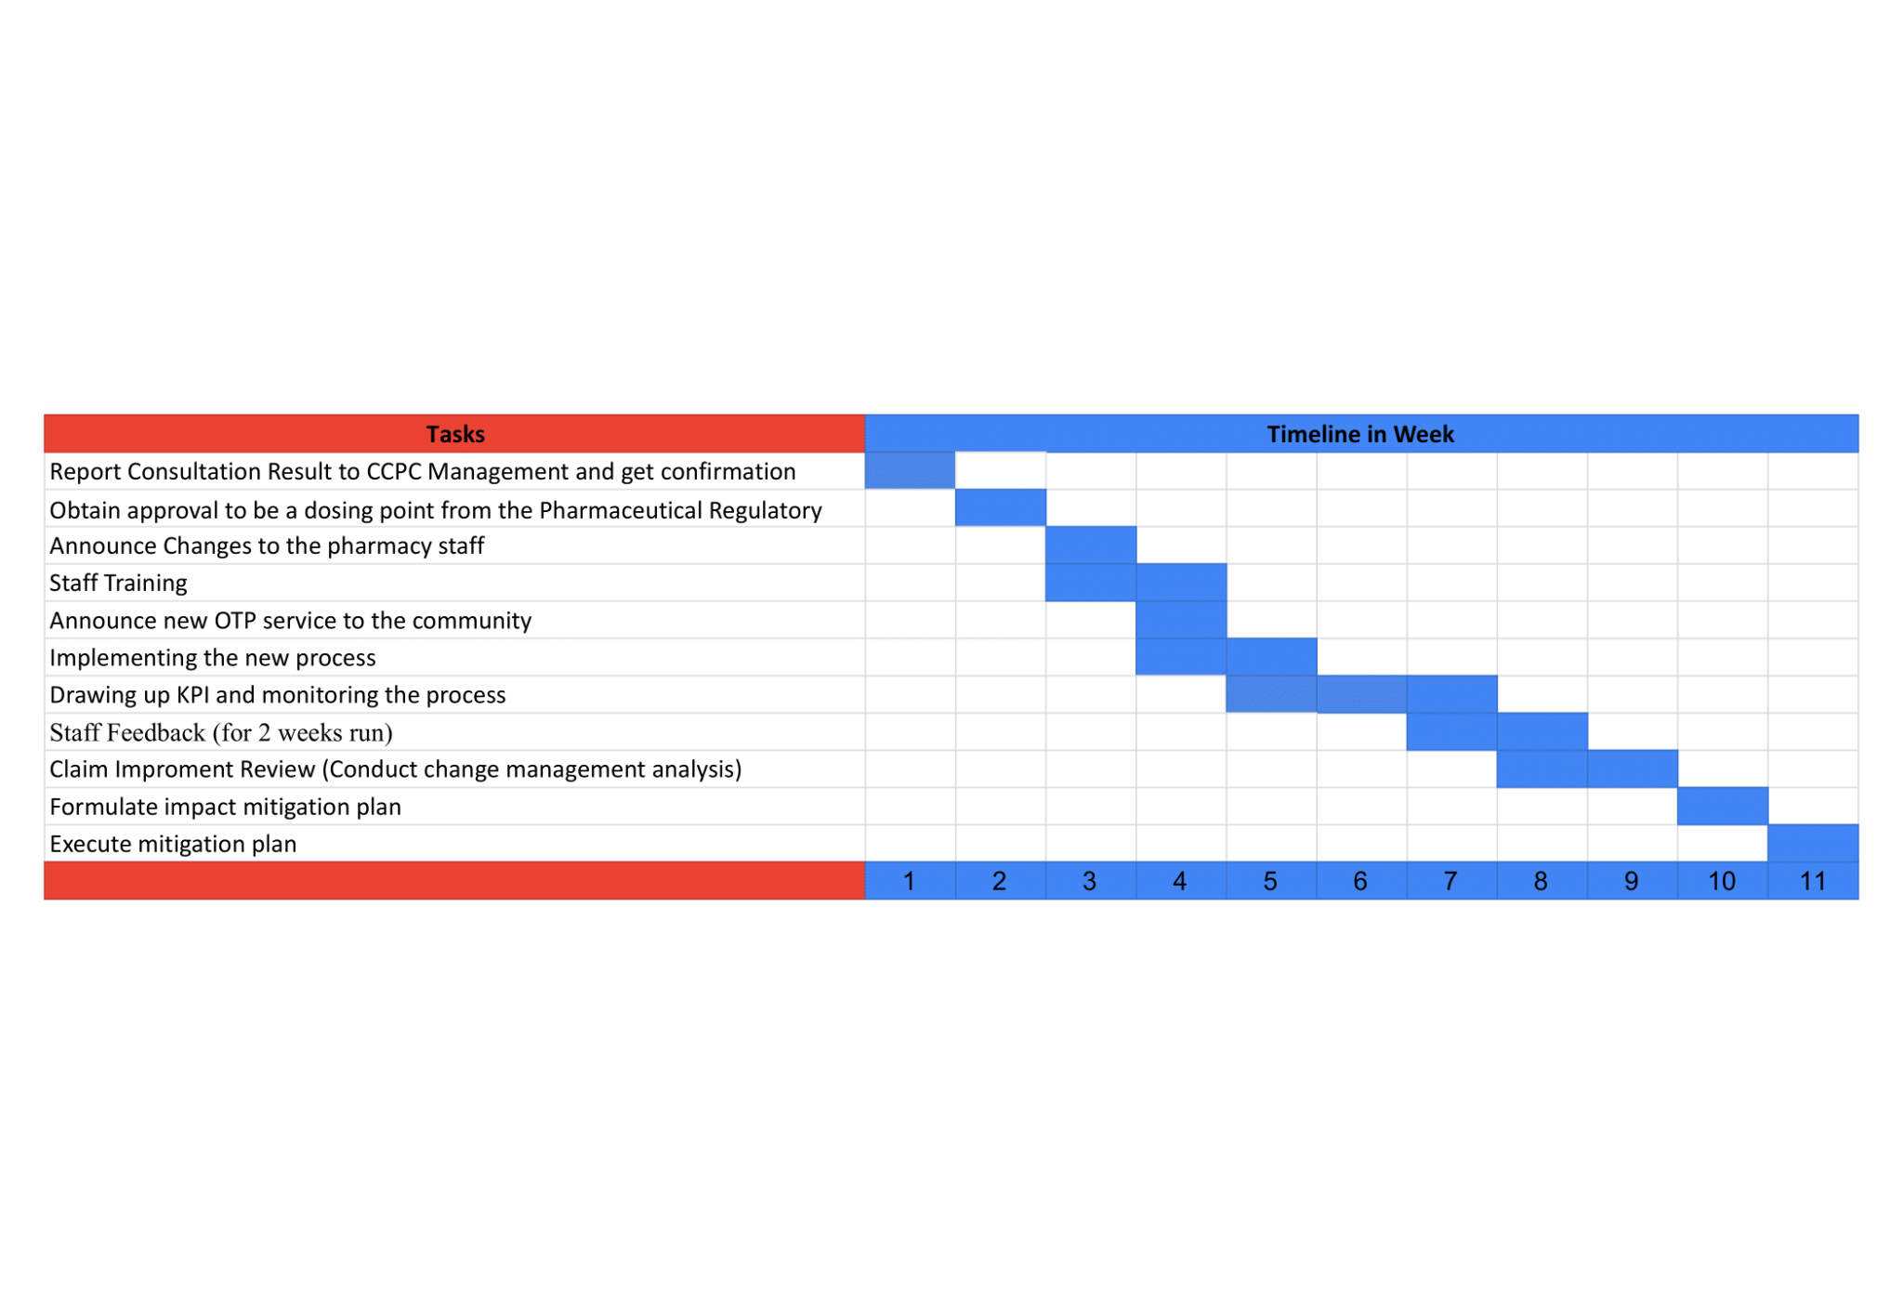

**4.2 Financial Analysis**

In New South Wales, there are 30 patients receiving opioid medication for every 10,000 people (AIHW, 2021), around 0.3%. According to the Australian Bureau of Statistics (2022), there are 256,729 people in Parramatta. Additionally, CCPC takes up a 15% market share of the Parramatta pharmacy market. Hence, the CCPC market size is around 116 people. Furthermore, the average monthly expense for OTP patients is $214 and 44% of this cost is dispensing fees (Tran et al., 2022), which means the average cost for OTP patients is $94.16 per month, and then $1129.92 per year. Therefore, using this cost to multiply the 116 customers, the result would be the future revenue estimation of the OTP service, $1,31,070.72. The revenue of CCPC in 2021-2022 was $2,589,657, hence, the new OTP service would bring around a 5% revenue increase for CCPC. Additionally, the revenue will be achieved from the delivery fee of the OTP medicine to the patients, charging $10 for each delivery.

The launching of this package does not require a large amount of initial investment for the facilities. For the OTP launch, as mentioned by the Pharmacy Guild of Australia NSW Branch (N.A.), after obtaining clearance from NSW Health's Pharmaceutical Regulatory Unit, the community pharmacies can offer an opioid treatment program. There is no mandatory equipment required for the pharmacy to become the OTP provider. Hence, for the expected cost of providing OTP service, the major component would be the additional salaries for hiring an additional pharmacist in charge and an additional practice assistant, around $12470 per month. The majority funding will be used to cover the additional salary of these two people in the early stage. After this package reaches the breakeven point, CCPC will use the free cash flow to pay their salaries. In addition, it would spend $8,000 on advertising that CCPC will deliver the OTP service to make more OTP patients know where they could achieve the OTP treatment in Parramatta.

OTP is supported by the NSW Ministry of Health and this package is cost-efficient. Hence, this new package is long-term sustainable, as the OTP aims to achieve a non-drug environment.

**5.0 Change management**

**5.1 Impact assessment**

| **Proposed Change** | **Impact on stakeholders** | | |
| --- | --- | --- | --- |
| **Stakeholder** | **Impact** | **Severity** |
| Open from Monday to Sunday | Pharmacy | Attract more customers  More expense on the salaries | H |
| Pharmacist | More workload to deal with more customers coming on weekends | H |
| Patients | Can come to the pharmacy on weekends, won’t affect their treatment because of any holidays | H |
| Register as a dosing point | Pharmacy | The pharmacy must obtain the approval to be a dosing point | H |
| Pharmacist | Pharmacists should be familiar with the whole process of the opioid treatment | H |
| Patients | More convenience for the patients | H |
| Community | Might bring unsafety to the community because of the opioid dependent patients | H |
| Supervise patients to take dose (for supervised dosing required patients) | Pharmacist | More work | M |
| Patients | No impact | L |
| Deliver the medicine to the patients | Locum pharmacist | More work to arrange for the delivery to the patients | M |
| Practice assistant | More work to deliver the medicine | H |
| Patients | Can stay at home and receive opioid treatment without delay | H |

**5.2 Impact mitigation**

**Hire more employees and provide all the staffs with standard training**

As the pharmacy will provide OTP and home delivery service for the opioid dependent patients, the workload of all the staff needs to be reduced by hiring more staffs, especially the skilled pharmacist that can dispense and supervise of dosing of methadone and buprenorphine or even do the delivery service. Besides, the pharmacy can provide training for all the staff, including the whole process of OTP, the precautions of the medicine and home delivery process.

**Use automotive machine for pharmacists**

As the dose of medicine is dependent on the situation of each individual patient, the pharmacists have to measure and dispense the dose to patients one by one, which adds to the pharmacists’ burden. With high technology like the automotive dispensing machine, pharmacists can get the medicine from the automotive dispensing machine without wasting time looking for them, which can reduce their burden and reduce the possibility of pharmacists getting the wrong dose for patients.

**5.3 Risk analysis**

| **Ref** | **Risk** | **Who is impacted and How** | **Likelihood** | **Consequence** | **Mitigation**  **Action** |
| --- | --- | --- | --- | --- | --- |
| 1 | Delayed delivery of the OTP medicine to patients | The OTP-dependent patient could not get the treatment on time which might have a negative impact on their recovery | Moderate  (depends on the different daily demands of the OTP patients) | Major  (This would decline the reputation of CCPC) | Add a vehicle to deal with the high demand for OTP-medicine delivery |
| 2 | Resistance of the pharmacist to deliver the OTP service | The OTP-dependent patient might lose the opportunity to achieve the treatment in Parramatta | Moderate  (depends on the different attitudes of pharmacists) | Major  (This would hinder the daily operation of CCPC) | Deliver staff training, which will ensure all the staff know the benefit and the entire procedure of the OTP and addresses their concerns about providing the OTP service |
| 3 | Negative impact on customer flow | The existing and potential customers of CCPC, as their security will be concerned. | Likely (people are always concerned about their own safety) | Major  (This would reduce the revenue. CCPC might not be able to maintain its daily running) | Divide a private consultation room for dispensing the OTP medicine to patients, which could also protect their privacy |

**6.0 Conclusion & Recommendation**

In summary, with the rapid development of computing data analysis and its wide application to the medical system, it is an inevitable trend that OTP will be one of the main medical treatments to opioid dependent patients. Even though OTP still has some risks and impacts, in the long term, its advantages outweigh the disadvantages for all stakeholders. For opioid dependent patients, it is a lot more convenient and safer. For pharmacies, it is much more efficient to keep accurate, manageable, and sustainable data of the opioid dependent patients’ disease history. These advantages not only help opioid dependent patients access better service, help them to detoxify, but also enhance the sustainability and financial growth for the government, the communities, and the pharmacies.

**7.0 Reference**

Australian Bureau of Statistics. (2020). *Region summary: Parramatta.* <https://dbr.abs.gov.au/region.html?lyr=sa3&rgn=12504>

Australian Bureau of Statistics. (2022). *National, state and territory population.* https://www.abs.gov.au/statistics/people/population/national-state-and-territory-population/mar-2022

Australian Institute of Health and Welfare. (2021). *Clients receiving pharmacotherapy treatment on a snapshot day, by state/territory, 2011 to 2021.* AIHW. <https://www.aihw.gov.au/reports/alcohol-other-drug-treatment-services/national-opioid-pharmacotherapy-statistics/contents/clients>

Fred. (n.d.). *ePrescriptions.*<https://www.fred.com.au/what-we-do/eprescriptions/>

Mehmood, A., Mehmood, F., & Song, W. C. (2019, October). Cloud based E-Prescription management system for healthcare services using IoT devices. In *2019 International Conference on Information and Communication Technology Convergence (ICTC)* (pp. 1380-1386). IEEE.

Pharmacy Guild of Australia NSW Branch. (N.A.). *Opioid Treatment Program Resource Manual.* <https://www.guild.org.au/__data/assets/pdf_file/0025/83455/Opioid-Treatment-Program-Resource-Manual.pdf>

Lintzeris, N., Hayes, V., & Arunogiri, S. (2020). Interim guidance for the delivery of medication assisted treatment of opioid dependence in response to COVID-19: a national response. *Sydney: The Australasian Professional Society on Alcohol and other Drugs (ASPAD)*.

Tran, A. D., Chen, R., Nielsen, S., Zahra, E., Degenhardt, L., Santo Jr, T., ... & Larance, B. (2022). Economic analysis of out-of-pocket costs among people in opioid agonist treatment: A cross-sectional survey in three Australian jurisdictions. International Journ*al of Drug Policy, 99*, 103472. <https://doi.org/10.1016/j.drugpo.2021.103472>

Nazaroff, D. (2020). *Western Sydney needs a safe drug injecting facility.* Western Sydney University. <https://www.westernsydney.edu.au/newscentre/news_centre/story_archive/2020/western_sydney_needs_a_safe_drug_injecting_facility>

NSW health. (N.A.). *NSW Opioid Treatment Program*. <https://www.health.nsw.gov.au/pharmaceutical/patients/Pages/otp-for-patients.aspx>